20.54: (a) 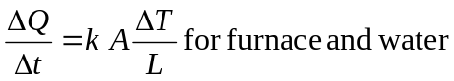

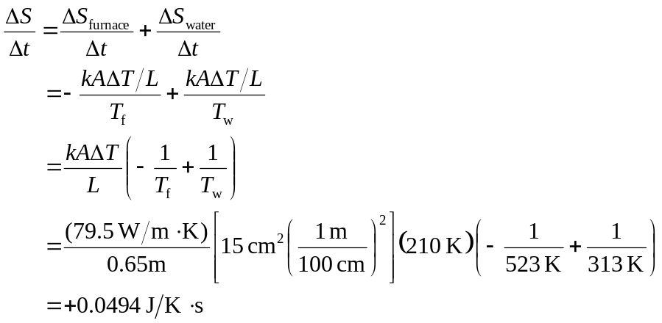

(b) 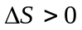means that this process is irreversible. Heat will not flow spontaneously from the cool water into the hot furnace.

